Lost Pet
“(Pet’s Name)”
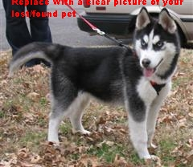

Lost in the vicinity of (nearest intersection)

Please contact (your name) at (your phone number)

